Great Bradley Church, Suffolk: Grave Number 95
Walter Webb
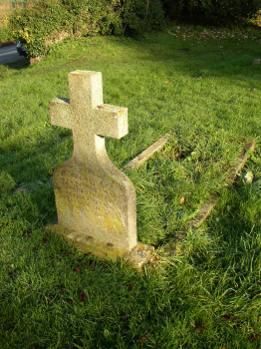 | IN  LOVING  MEMORY OF  WALTER WEBB  WHO PASSED AWAY  JUNE 20th 1920  AGED 49 YEARS  THROUGH THE CROSS  UNTO THE CROWN
