Great Bradley Church, Suffolk: Grave Number 87

Annie MacKean, Eliezer Biggins Emerson MacKean and John Alexander Furnival MacKean
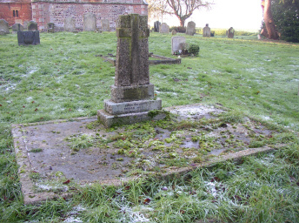 | ANNIE MACKEAN  * 8th NOVEMBER 1856  + 8th MAY 1936  IN LOVING AND GRATEFUL MEMORY  ------  AND OF HER ELDER SON  BRIGGS MACKEAN  * 3rd MARCH 1894  + 16TH JAN 1956  The stone cross commemorates Annie MacKean 1936, Eliezer Biggins Emerson MacKean 1956 (her elder son shown on the grave as ‘Briggs’) and John Alexander Furnival MacKean 1983 [cremated remains].
