Great Bradley Church, Suffolk: Grave Number 79

Richard Hayward and Sophia Hayward
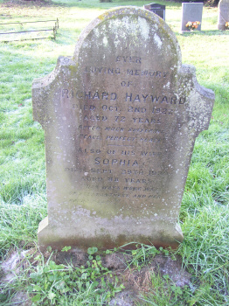 | In  ever  loving memory  of  Richard Hayward  Died Oct 2nd 1922  Aged 72 years  'After much suffering  Peace Perfect Peace'  __  Also his wife  Sophia  Died Sept 29th 1939  Aged 88 years  'Here ways were always  of pleasantness and  paths peace'  The is a footstone engraved 'R.H 1922'
