Great Bradley Church, Suffolk: Grave Number 60
Thomas Edward Martin

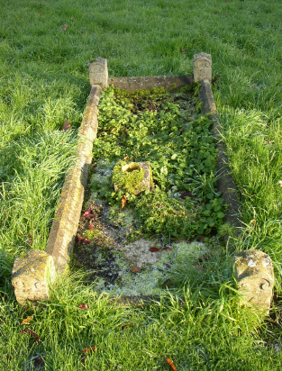 | Buried 1956  Stone Grave with kerb

