Great Bradley Church, Suffolk: Grave Number 3
Walter Henry Rawlinson

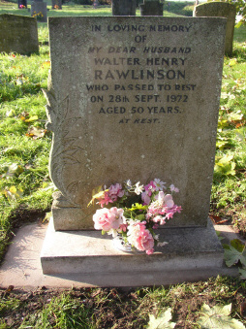 | IN LOVING MEMORY  OF  MY DEAR HUSBAND  WALTER HENRY  RAWLINSON  WHO PASSED TO REST  ON 28TH SEPT 1972  AGED 50 YEARS  AT REST
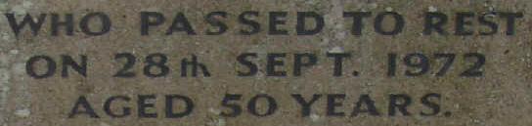
Walter’s wife, Queenie, helped confirm a number of the burial plots in 2004

