Great Bradley Church, Suffolk: Grave Number 37

Grace Ellen

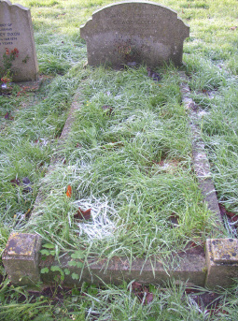 | In loving memory of Grace Ellen  The Loving wife of John Dixon  ....more ...
