Great Bradley Church, Suffolk: Grave Number 35
Matthew Winston Claydon
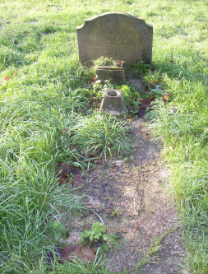 | IN LOVING MEMORY OF  MATTHEW WINSTON  CHARLTON  WHO DIED 12TH APRIL 1958  AGED 58 YEARS  AT REST
