Great Bradley Church, Suffolk: Grave Number 24
Osyp Dumycz
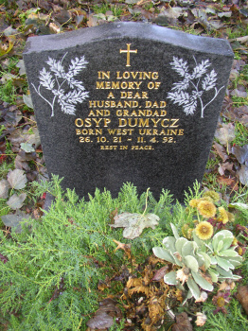 | IN LOVING  MEMORY OF  A DEAR  HUSBAND DAD  AND GRANDAD  OSYP DUMYCZ  BORN WEST UKRAINE  26.10.21 - 11.4.92  REST IN PEACE
