Great Bradley Church, Suffolk: Grave Number 201
Queenie May Rawlinson

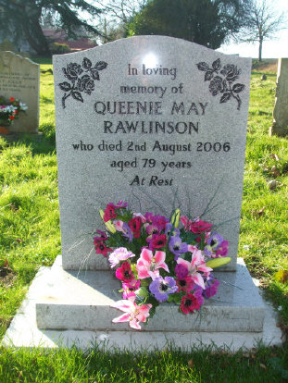 | In loving  memory of  QUEENIE MAY  RAWLINSON  who died 2nd August 2006  aged 79 years  At Rest
Quennie May Rawlinson died 2nd August 2006. Wife of Walter Rawlinson [grave No 3 on plan]. Much loved and respected in the village where she lived all her life. A great helping in compiling this record by providing local knowledge. Polished Face Grey Memorial erected in 2007 by undertaker H J Paintin.

