Great Bradley Church, Suffolk: Grave Number 199
Colin Maurice Pettit

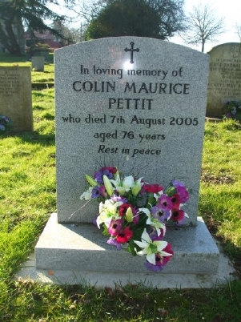 | In loving memory of  COLIN MAURICE  PETTIT  who died 7th August 2005  aged 76 years  Rest in Peace
Colin Maurice Pettit died 7th August 2005 aged 76. Born 29th January 1929. Partner of June Grey and lived in Evergreen Lane Great Bradley for 23 years. An appreciation of his life appeared in the Bradley Bugle September 2005. Polished Grey Memorial erected in 2006 by undertaker H J Paintin

