Great Bradley Church, Suffolk: Grave Number 194
Small Triangular Tomb Grave with skull and skeleton engravings. Small, partly broken carved Head Stone, 2 holes drilled through, lying horizontal with Skull and old style writing. Markings indicate John no 1 ….[ presume son ] Born 1703. The writing is in old English and heavily eroded.
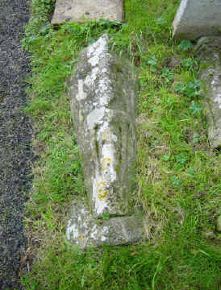 | 