Great Bradley Church, Suffolk: Grave Number 180
James Galley and his wife Ann.
Flagstone & Foot Stone marked JG 1868 - AG 1871. James worked for local Landowner Hanslip Long, No 128, as a labourer. His daughter Caroline was also a member of the household as maid servant when she married in 1847 to Alfred Ashby. Either James or George was foreman at the Hall and needed to report each evening to Daniel Long.

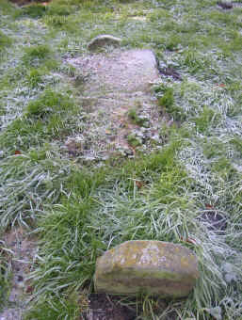 | TO THE MEMORY OF  JAMES GALLEY  WHO DIED DEC 1 1868  ALSO  ANN HIS WIFE  AGED 71 YEARS  WELL DONE THEE GOOD AND FAITHFUL SERVANT  ENTER THOU INTO THE JOY OF THY LORD  ERECTED BY HANSLIP LONG IN RESPECT OF  .....................  WHO DIED FEB 3 1871  Footstone has  J.G  1868  A.G  1871

