Great Bradley Church, Suffolk: Grave Number 176
Charles David William Ryder

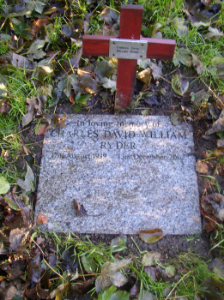
Small wooden undertakers cross and marble cremation tablet inscribed

In loving memory of
CHARLES DAVID WILLIAM RYDER
17th August 1939 - 13 December 2002

