Great Bradley Church, Suffolk: Grave Number 170
George Galley
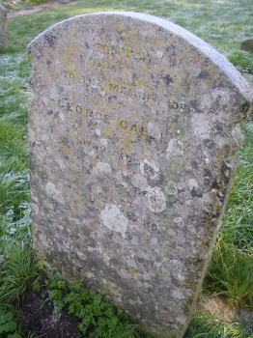 | SACRED  TO THE MEMORY OF  GEORGE GALLEY  WHO DIED  JAN 26 1868  AGED 74 YEARS
Other Galley family Graves are numbers 170,171,180

