Great Bradley Church, Suffolk: Grave Number 142
John Frost and Ella Beth
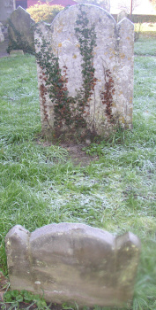  Headstone & Footstone | IN  MEMORY OF  JOHN FROST  WHO DIED SEPT 11TH 1838  AGED 32 YEARS  ALSO  ELLA BETH  DAUGHTER OF THE ABOVE  AGED 8 MONTHS  Footstone has  A.F

