Great Bradley Church, Suffolk: Grave Number 136
Josiah Nice
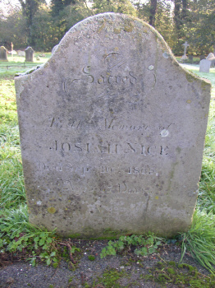 | SACRED  TO THE MEMORY OF  JOSIAH NICE  WHO DIED SEPT 10 1869  AGED 67 YEARS  Footstone reads:  JN  1869
