Great Bradley Church, Suffolk: Grave Number 134
Arthur Hanslip
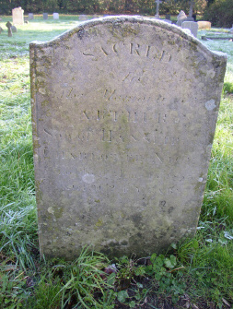 | SACRED  TO THE MEMORY OF  ARTHUR  SON OF HANSLIP AND  CHARLOTTE NICE  WHO DIED JUNE 15th 1853 AGED 24  Footstone has:  A.N
