Great Bradley Church, Suffolk: Grave Number 128
Hanslip Long
Headstone and footstone present
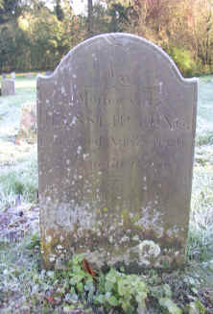 | IN  MEMORY OF  HANSLIP LONG  WHO DIED APRIL 8th 1829  AGED 60 YEARS  Footstone has:  H.L  1829  See also Granddaughter Ida, plot 46
Hanslip was baptised on 19 May 1769 at Brinkley. He became a tanner in Kings Lynn. The money for his apprenticeship came from the will of a John Hanslip of Lakenheath. His brothers William and Joseph and sisters Elizabeth and Tabitha were also legatees. Mary, the mother of these siblings was John Hnaslip's sister. Tabitha married William Nice of Bulmer in Essex and they then came to live in Great Bradley. They had children called Hnaslip
William married Elizabeth Cotton and they lived in Brinkley. They too had children called Hanslip

