Great Bradley Church, Suffolk: Grave Number 127
Clarissa Nice
Headstone and footstone present

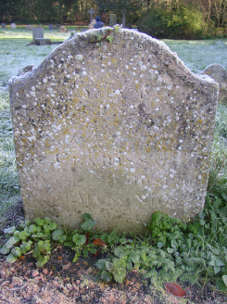 | SACRED  .....[words eroded] ..  CLARISSA  DAUGHTER OF JOSIAH  AND MARY NICE  WHO DIED [date eroded, probably 1800]  Footstone has  C. N  [date erroded]

