Great Bradley Church, Suffolk: Grave Number 11
Lloyd Morling

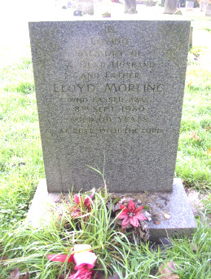 | IN  LOVING  MEMORY OF  A DEAR HUSBAND  AND FATHER  LLOYD MORLING  WHO PASSED AWAY  8TH SEPTEMBER 1980  AGED 66 YEARS  AT REST WITH THE LORD  The Burial Register records his name as Harold Morling
