Great Bradley Church, Suffolk: Grave Number 111
Jerry Cook
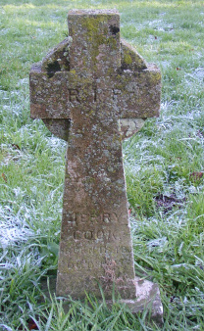 | R.I.P  JERRY COOK  BORN 1848  DIED 1917  BY FAITH  ARE YE SAVED
