Great Bradley Church, Suffolk: Grave Number 104
Yvonne Margaret Goody
This double depth grave will receive Morris Goody

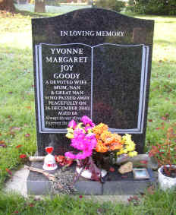 | 