Great Bradley Church, Suffolk: Grave Number 100
Kevin Andrew Goody
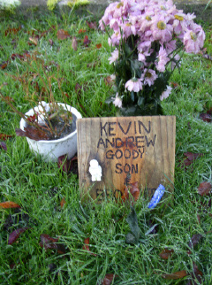 | KEVIN  ANDREW  GOODY  SON  &  BROTHER
