Great Bradley through the Ages: 6. The Mediaeval Period – Part a: 13th & 14th Century
We know that Great Bradley church was built between 1071 (11th Century) & 1150 (12th Century) in the Norman style. The period after The Norman conquest is known as the Middle Ages or Mediaeval Period and is roughly assumed to last up to the 15th Century. In Great Bradley this must have been a period of great change. The plan of the church shows that the chancel (the area in front of the altar) of the original Norman church would have been longer than it is now but was shortened in the early 14th Century. The magnificent tower is also 14th century.
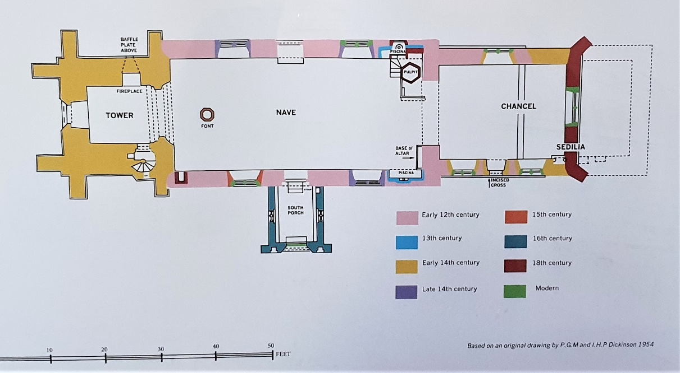

Our church follows the tradition of the altar being at the east-end. The plan of the church, which is hung in the south porch, shows that the Norman structure comprises the current nave (the main part of the church) and some of the chancel (the area in front of the altar)..
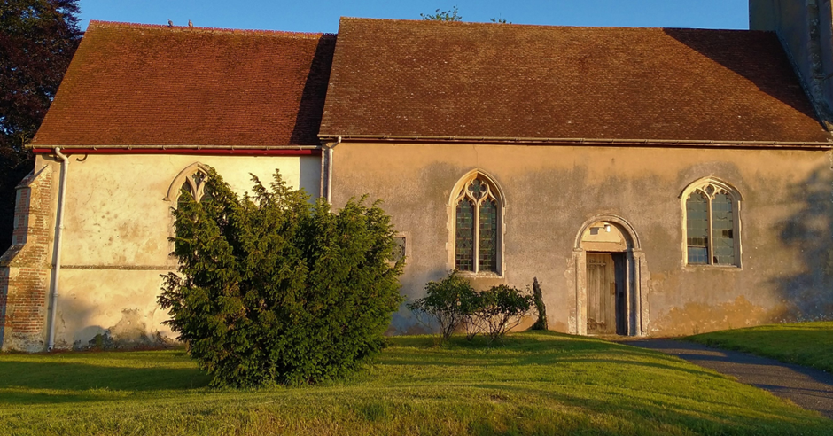
The most impressive Norman features are the north & south doors (excluding the south porch, which is 16th century). The north doorway (facing the road) is plainer than the south, which is similar to the Prior’s doorway at Ely Cathedral (and to a similar door in nearby Kirtling church).
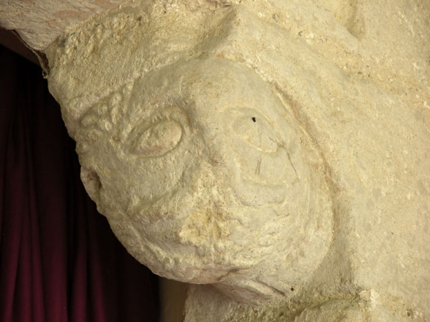
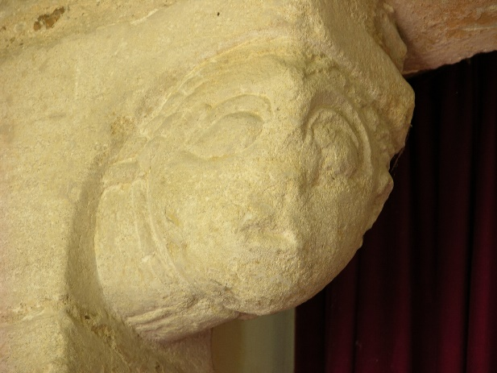
The jambs of the south door (inner vertical pillars) have corbels with projecting human heads facing across the doorway and turned slightly towards the porch. Both heads are carried on thick, horizontal, columnar necks carved with bands representing the collar of a tunic, as at Ely Cathedral. As at Ely one head is clean-shaven while the other is bearded. The western (left side) head is youthful and clean-shaven with bulging almond eyes under ridges for brows. The mouth is small, full-lipped and slightly open; a left ear only is shown, and the hair is indicated by a double row of elongated beading. Originally the angle of the block formed the nose, which ran down from the junction of the brows, but the nose is worn away now. The eastern (right side) head is similar, but with a short, striated jawline beard and a long moustache, curving up at the ends. There is no hair in the centre, indicating balding, and tufts at the sides shown as clusters of beading. A right ear only is shown.

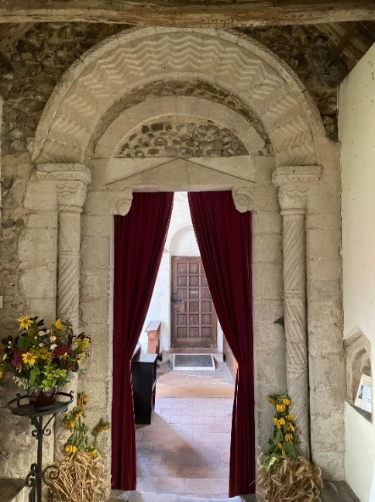
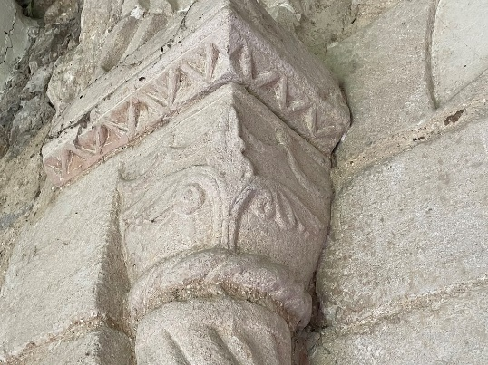
The arch is carved with a repeating chevron, consisting of four stepped bands. The outer and inner arch are filled with flints.
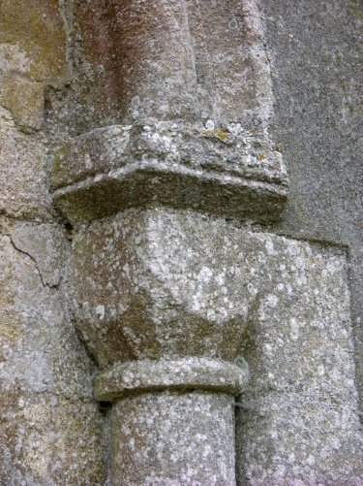
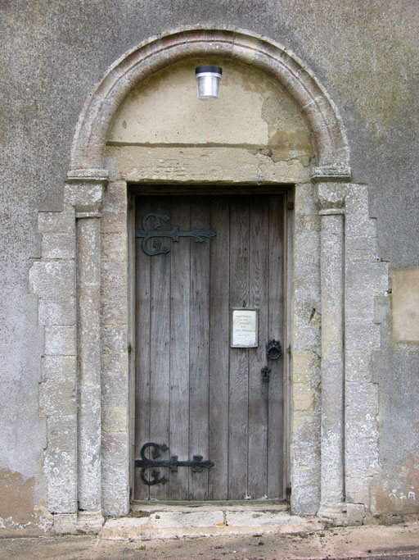
The outer arch support shafts are carved in sections with double-twist cable, which changes direction with each section. The sections are separated by triple rolls. The capitals on top of the pillars have motifs in the form of a double cusp at the top of each face and a stem splitting into three. The central branch terminates in a leaf with scalloped edges, while the side branches are furled leaves running horizontally across the side faces of each capital
The north door has plain, square jambs supporting a plain lintel and a tympanum (area under the arch) that has now been rendered with mortar. The lintel has a section that has been lost and repaired with flints and mortar. The pillars have hollow bases supporting cushion capitals. The eastern (left) one is a plain cushion with a square neck and the other has a fluted bell. The top part of the inner shaft (the capitals) are chamfered towards a collar at bottom of the capital.
Apart from the walls of the nave and the western end of the chancel, the other main Norman feature is the base of the chancel arch. The upper part of the arch itself is probably 14th century.
For more information see the village website https://greatbradley.weebly.com/romanesque-architecture.html

