Great Bradley through the Ages: 5. The Normans – Part a
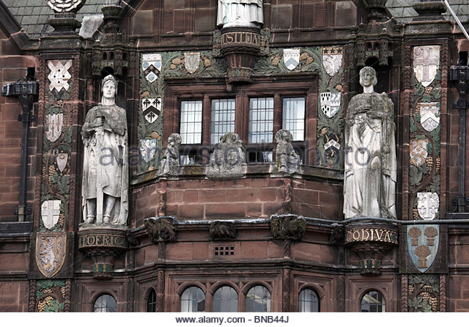
In October 1066 the Anglo-Saxon King Harold Godwinson, King of England and former Earl of Suffolk lost the Battle of Hastings to William the Conqueror and the kingdom of England passed from Anglo-Saxon rule to the Normans. The transition to full Norman rule took some 5 years in Great Bradley.
After the battle, Edwin Leofric (Eadwine in Anglo Saxon), the Overlord of most of the lands around Great Bradley (and whose sister had married Harold) returned to Mercia, hoping that William would be content to rule in southern England. When it became clear that he was not, Edwin reluctantly submitted to William at Barking in January 1067. In 1068 Edwin rebelled against William but soon submitted to the King once again.
Figure 1 Earl Leofric & Lady Godiva, Edwin Leofric's grandparents, depicted on Coventry City Hall
In 1071 though, Edwin travelled north to join with Edgar the Aetheling in Scotland with the intention to resist Williams rule (Edgar, a teenager, had been put forward as an Anglo Saxon King after Edward the Confessor’s death in 1066 before the Conquest). On the way to Scotland, Edwin was betrayed by his own men and killed.
The records show that the local lords of the land around Great Bradley (ultimately owned by Edwin) were also displaced in 1071. These were Ulf son of Mani Swart and Wihtgar Aelfricsson and someone called Bondi. It was at this point that his lands in Great Bradley passed from the Anglo-Saxons to the Normans.
At the time, Great Bradley and Little Bradley were just as one place called Bradley (an Anglo- Saxon word meaning Wide Clearing in a Woodland). The details of the land owners in Great Bradley are known because the Normans conducted of a survey between 1085 and 1086 of much of England to evaluate the taxes owed to the King. We know this survey as the Domesday Book. Five different land holdings are identified along with their owners, the people and animals on the land and what the taxable value was. A population of 56 households was recorded, putting Bradley - believe it or not - in the top fifth of largest settlements recorded in the Domesday Book. Haverhill had 54 households, Thurlow had 60 and Bury St Edmunds had 207. London had a population of 10,000.
Entry in the Domesday Book describing Bradley

By 1086 the five packets of land in Bradley listed as being under the control of three owners: Bury St Edmunds Abbey and the Normans, Richard Son of Count Gilbert and Richard of Tosny.
In Saxon times, the Abbey in Bury St Edmunds held 2 pieces of land. One had 12 Freemen, 2 smallholders and enough land to be ploughed by 4 men’s teams (of oxen); there was 2 acres of meadows and it was worth 1 pound, 1 shilling and 2 pence. The Abbey was permitted to retain this land after the Norman Conquest.
Domesday Book Entry for land that St Edmunds Abbey lost

The other piece of land had 2 Freemen, 2 men’s teams of oxen and 2 acres of meadow. It was worth 1 pound 2 shillings and 5 pence. By 1086 it had been granted to Richard son of Count Gilbert
The third piece of land in Bradley had been controlled by the Saxon Wihtgar (son of Aelfric). It had 2 Freemen, 1 men’s team of oxen and 1 acre of meadow. It was worth 17 shillings and 5 pence. This land was also given to Richard son of Count Gilbert.
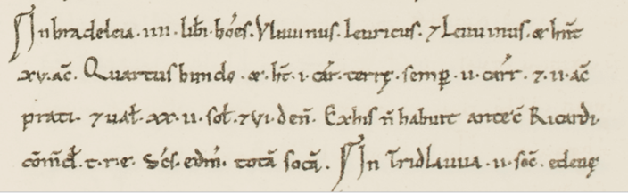
Entry for land in Bradley for Richard son of (Count) Gilbert

The fourth piece of land was controlled by someone called Bondi and four Freemen. There were 2 men’s plough teams and 5 acres of meadow. It was worth 1 pound, 2 shillings and 5 pence. This land was also taken over by Richard son of Count Gilbert.
Entry for land in Bradley for Richard son of (Count) Gilbert

The last piece of land in Bradley was the biggest and most valuable. In Saxon times it was controlled by Ulf (son of Manni Swart). On the land were 14 villagers and 6 slaves, 12 small holders and there were 3 lord's plough team and 7 men's plough teams. There was 13 acres of meadow, woodland with 500 pigs, 1 cob, 18 cattle, 53 pigs, 63 sheep, 7 goats and a beehive. Significantly, there was also a church with 0.12 acres of land. In total the land was worth 8 pounds. This land was given to Robert de Tosny. Tosny is a town, today about the size of Newmarket, between Rouen and Paris is northern France. There is no evidence of a Saxon church in present day Great Bradley so the church mentioned here must be in present day Little Bradley - which even today has evidence of its have Anglo-Saxon origins.

Domesday entry for land in Bradley given to Robert of Tosny
The coming of the Normans not only meant changing ownership of the land but a different way of life. And in the near future, it would be the exchange of land between the new Norman rulers that would bring about the separation Bradley into Great and Little Bradley.
For more information on Bradley and the Domesday book see https://opendomesday.org/place/XX0000/great-and-little-bradley/

