**Great Bradley through the Ages: 3. The Iron Age and the Romans**

*This information builds on the History of Great Bradley published in 2000 by a team of villagers led by Barbara Buchs and is downloadable from the website at* [*https://greatbradley.weebly.com/published-histories.html*](https://greatbradley.weebly.com/published-histories.html)

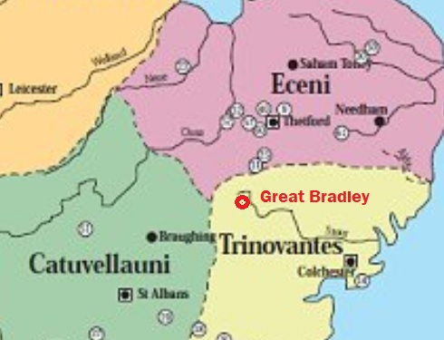The first Iron Age settlers came from southern Holland/ eastern Belgium in about 500BC. ‘Celts’ is another term used for Iron Age peoples. A bit like today, where Great Bradley sits close to the border of Suffolk, Cambridgeshire and Essex, it was close to the borders of three main Iron Age peoples.

To the north were the Iceni, originally from France; to the west were the Catuvellauni from Belgium and the last major group to settle here were the Trinovantes, probably also from Belgium. The map shows Great Bradley as being in the territory of the Trinovantes, but we can’t be sure exactly where the borders were. Some of the woodland in the area would have been cleared by this time as farming had begun to be practiced.

Approximate areas occupied by Iron Age peoples

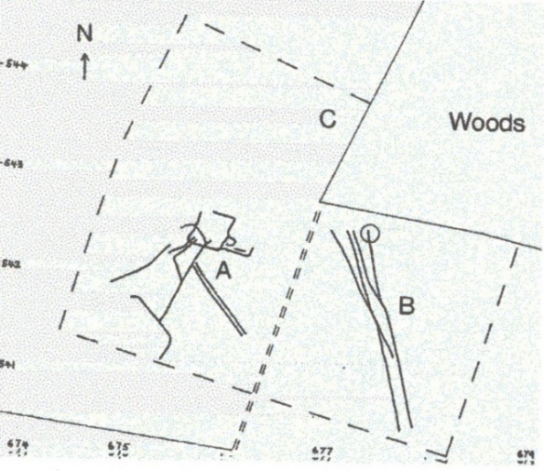A few items that have been found around Great Bradley that can be specifically dated to the Iron-Age. Just south of Bradley Park Wood there are crop marks showing trackways. They were discovered by the Haverhill & District Archaeology Group who conducted a field walk of the area in 1985. The tracks are grouped in two sets, marked A & B on this diagram. Iron age pottery has been also found, including some with burnt flint grit and one sherd from a `Belgic' jar, which was one of the earliest types of pottery to be found in the UK created with a potter’s wheel.

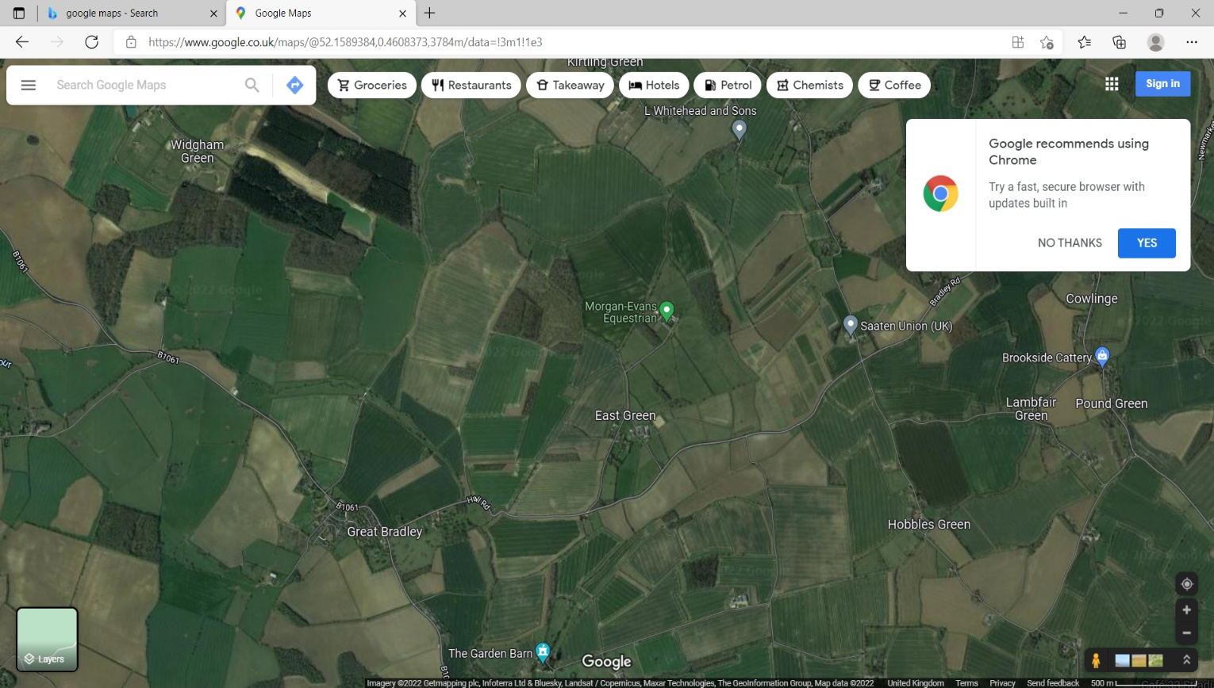

Area of diagrams

Bradley Park Wood

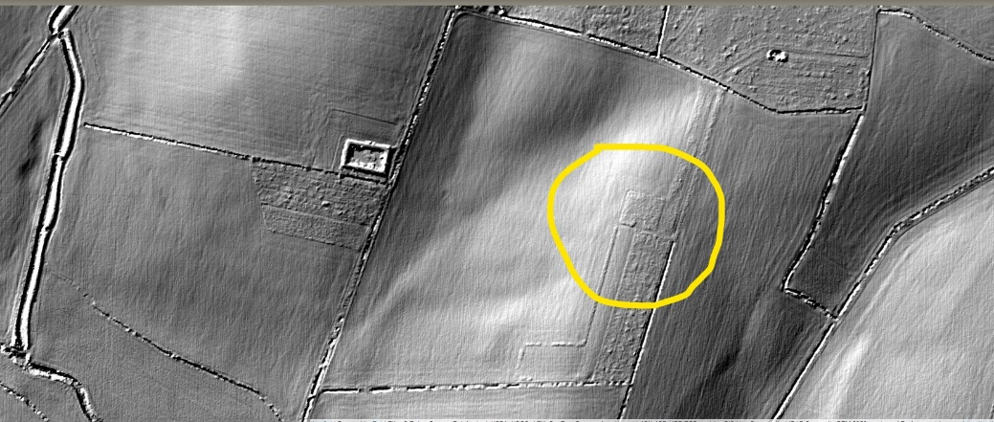There is also a possible hut site below Bradley Park Wood, which shows up in the square shape on this black & white LIDAR (Light Detecting And Ranging) image taken with a laser from a plane. Because the area round Great Bradley has been extensively farmed, the effect of the plough has often removed features, thus making identification difficult.

The Romans first came to Britain in AD43 and gradually took over the lands of the Iron Age/ Celtic people. Around Great Bradley there was an alliance between the Celtic people and the Romans to enable joint government. When the King of the Iceni, Prasutagus, died in about 62AD he willed half his territory to the Romans hoping it would bring further peace.   
The Romans, though, decided they would take all the land.

LIDAR image of fields below Bradley Park Wood

The Celtic peoples had other ideas. Led by Queen Boadicea (or Boudica) of the Iceni they, and the Trinovantes, attacked and defeated the Roman army in 60/61AD. They destroyed the three major Roman towns of Londinium (London), Verulamium (St. Albans), and Camulodunum (Colchester), killing many thousands of citizens. The revolt was eventually suppressed and the Roman rule then became stronger across the region.

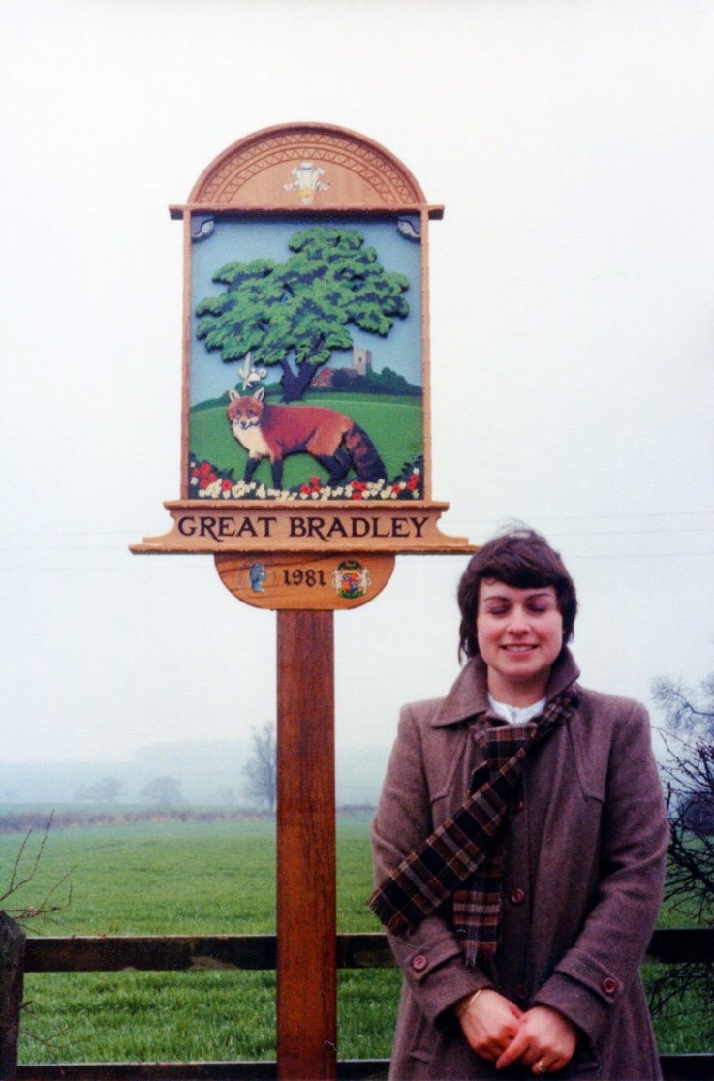  
Until 2011, the only Roman find had been a coin from the Constantine Iperiod (*AD* 30*6* - 33*7*). It was found near Hart Wood south of the village (see map) by farmworker and resident of the village, Cyril Potter. Its importance was such that it was depicted on the bottom left of the first village signed, designed by Wendy Barnes, which stood from 1983 – 2008 before being replaced by the current one.

In 2011 a pipeline was buried alongside Kirtling Brook and the River Stour.  This enables more water from the reservoir at Kirtling to be moved to Essex without having to put increased volumes of water in these rivers, which could disrupt the ecosystem of both the brook and the River Stour. The archaeological surveys undertaken when the pipeline was laid have been the most thorough in the area.



Test pits made during the pipeline survey

During these excavations part of an early Roman settlement was found. It is just across the river Stour from the church and covered an area of at least 50m but continued beyond the excavation area, so was not investigated further. There were at least two phases of Roman remains dating from the 2nd to 4th century AD including possible enclosures around a cobbled surface. The cobbles were of chalk, flint and sandstone about 6-10cm in size. It is uncertain what it represented, perhaps a route way as it was in a hollow 20m long and 10m wide.

Three Roman coins were also found in the area along with some pottery. One coin was a brass sestertius from no later than AD 102 in the Emperor Trajan’s reign. The other coins are later but only one is dateable because of their poor condition; It is attributed to the Valentinian dynasty (AD 364-78).

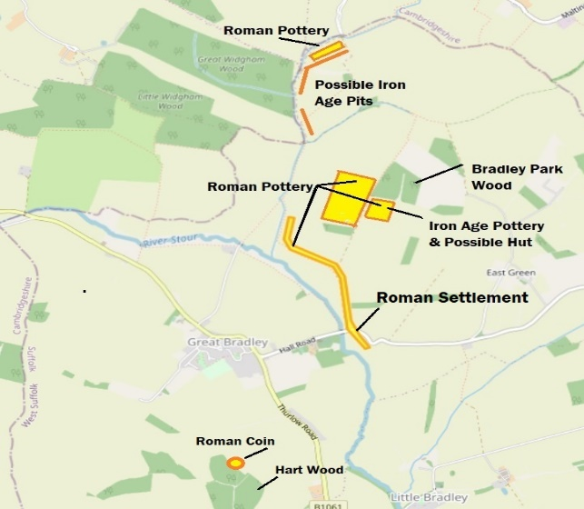

Location of Iron Age and Roman era finds

Over 100 pottery finds and some tiles have also been found west of Bradley Park Wood. They are mainly 3rd – 4th century and include bowls from the Oxford area; a white coloured lipped pouring bowl from the Peterborough area called Nene Valley mortaria; and reddish/brown Much Hadham bowls and jars from near Bishops Stortford. In addition, some Roman pottery has been found near the old windmill mound at the top of Bradley Hill.

For more on the Romans see the village website at <https://greatbradley.weebly.com/romans.html> or for the background on the village sign see <https://greatbradley.weebly.com/village-sign--garden.html>