Great Bradley through the Ages: 1. How our landscape was formed
The information builds on the History of Great Bradley published in the year 2000 by a dedicated team of villagers led by Barbara Buchs. It is downloadable from the website at https://greatbradley.weebly.com/published-histories.html
This area of the country was amongst the latest to be formed, during the Tertiary period (66 to 3 million years ago). It contains some of the youngest rock in the British Isles. The landscape surrounding Great Bradley is the result of the joint effects of past glaciation and the agricultural alteration of the land.
The land has spent much of its time under the sea, and the chalk which lies beneath the whole area was laid down about 140 million years ago. Minute skeletons of lime-secreting algae were deposited forming the white chalk, while mixed in it are nodules of silica, forming flints. Later the chalk came to the surface and was worn into a landscape by rivers and streams. Information from boreholes have shown that this landscape was rather different from that of today, with a river cutting away the chalk beneath where Mill House now stands (first house on left hand side as you come into the village from Newmarket). Sand and gravel were laid down in the river's valley. The presence of the chalk is water is why the water is so 'hard' (water for Great Bradley being drawn from a borehole in Great Wratting, on the left just past the pub).
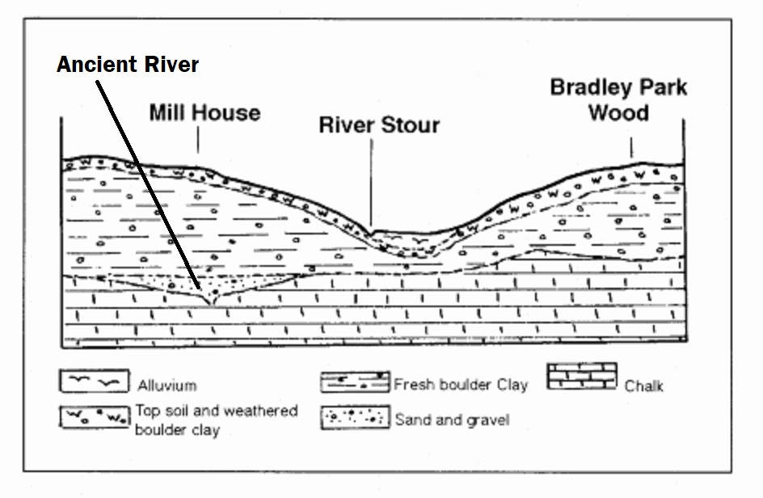
Cross section through Bradley Hill (left) and the River Stour Valley to show the underlying geology
Then came the ice ages from about one million years ago. As the ice sheets travelled across the land they transported large amounts of material caught up in the frozen mass. When the ice melted, these boulders, pebbles and very fine particles together were deposited over vast areas, and formed a boulder clay layer 30-50m deep. This boulder clay covered the whole area of Great Bradley (as anyone who has dug a garden round here will be able to testify!).
With the ice melted, early rivers left gravel patches in areas of the clay. Some of the last of these show on the surface in Great Bradley, for instance near Spring Barn (the last houses out of the village on the left, going to Thurlow), The Fox and the Old Rectory at the Newmarket end of the village. The gravel can also be seen to the north east where the stream flows from Kirtling to the River Stour.
Map showing clay and gravel deposits near the surface on top of a chalk bedrock
The River Stour has shaped the present landscape. It is 47 miles (76km) long and Great Bradley is the first village along its length. Variations in climate and sea level over the past twelve thousand years or so mean that our river has varied greatly in size, and is possibly as small now as it ever has been.
The hills and valleys of Great Bradley have been scoured by rain, stream and river to form the parish where we live. Since 1954, rainfall in Great Bradley has been recorded at Great Bradley Hall. Annual rainfall has been 20" - 30" per year, with the wettest year being 2013 (35") and the driest, 1964 (17.62").
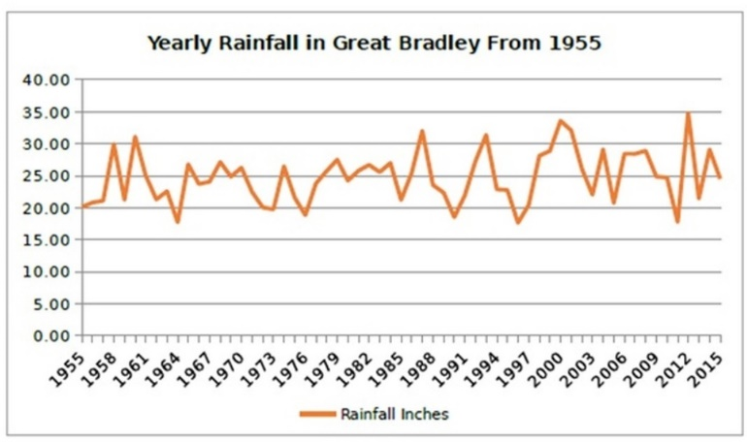
Although we are fairly low lying for the UK Great Bradley is quite high for Suffolk. There is a trig point at East Green, on the land occupied by the Bradley Oak Stud. It is recorded at 107 metres or 351 feet above sea level. This is 20m (65 feet) lower than the highest point in Suffolk, at Rede, but higher than any point in Norfolk!
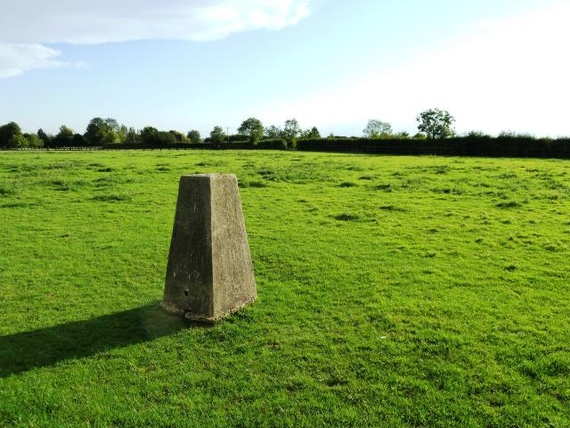
The Trig point at East Green

