Great Bradley Church, Suffolk: Grave Number 83
Harry John Martin and Winifred May Martin

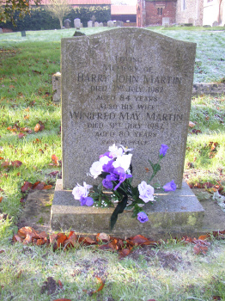 | IN  LOVING  MEMORY OF  HARRY JOHN MARTIN  DIED 2ND JULY 1982  AGED 84 YEARS  ALSO HIS WIFE  WINIFRED MAY MARTIN  DIED 31ST JULY 1982  AGED 80 YEARS
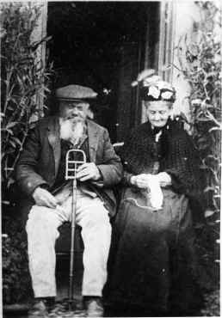
This is Mr & Mrs Harry Martin Senior outside Matthews Farm
(ie parents of the Harry buried in this plot)

