Great Bradley Church, Suffolk: Grave Number 67
Hannah Bishop 1919. Charles Bishop 1942.

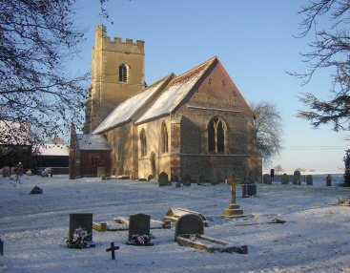

This is a double grave

