Great Bradley Church, Suffolk: Grave Number 47
Sarah Ann Bolding

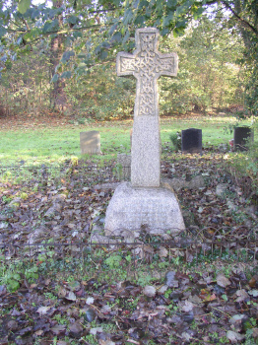 | IN LOVING MEMORY OF  SARAH ANN BOLDING  BELOVED WIFE OF DANIEL KENT LONG  BORN MAY 28TH 1848  DIED JUNE 16TH 1914  HE THAT BELIEVETH IN ME  HATH EVERLASTING LIFE  Sarah was the wife of Daniel Kent Long of Great Bradley Hall which he occupied in 1881 employing 47 men, 22 boys, 14 women and farming 1700 acres. Daniel was one of 10 or 11 children and his Uncle was Hanslip Long (plot 128). Sarah and Daniels's daughter, Ida, is in the adjoining plot 46
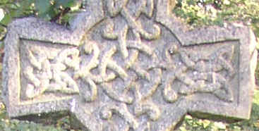

A plaque on a pew in the church erected by by their children commemorates Daniel and Sarah

