Great Bradley Church, Suffolk: Grave Number 42
Annie Cowans and Robert Cowans
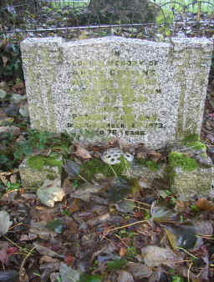 | IN  LOVING MEMORY OF  ANNIE COWANS  DIED JUNE 5TH 1960  AT EAST GREEN FARM  AGED 63 YEARS  ALSO OF  ROBERT COWANS  DIED NOVEMBER 14TH 1973  AGED 76 YEARS
