Great Bradley Church, Suffolk: Grave Number 33
Nellie Coot, 1958

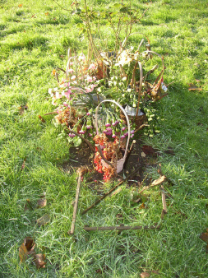

Its not certain if it is plot 33 or 34

