Great Bradley Church, Suffolk: Grave Number 31
Harry Balls and Julia Balls
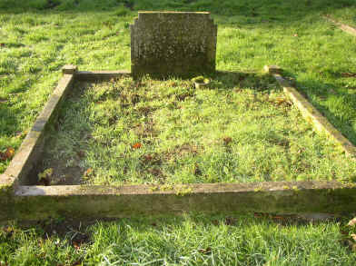 | IN LOVING MEMORY OF  HARRY BALLS  DEAR HUSBAND OF  JULIA BALLS  DIED JANUARY 18TH 1960  AGED 87 YEARS  ALSO  JULIA BALLS  Harry was a Boer War Veteran and coachman and gardener at Bradley Hall
