Great Bradley Church, Suffolk: Grave Number 30
Frank Claydon
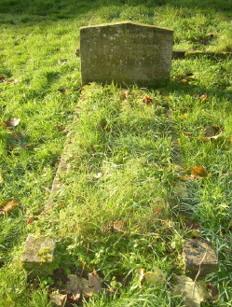 | IN  LOVING MEMORY  OF  FRANK CLAYDON  WHO DIED MARCH 20TH 1965  AGED 74 YEARS
We received this note from Frank Claydon's grandaughter in 2006:
Thank you so much for this site. As a little girl I often visited my Grandmother Violet Claydon who lived in St Johns College Cottages. My Grandfather Frank Claydon is buried in the churchyard. The Claydons seem to have lived in the village for a long time. It was wonderful to see all the pictures and details about the village. I am trying to find about my "Claydon" roots so might visit you in the future.

Thanks again
Frances Dyett

