Great Bradley Church, Suffolk: Grave Number 27

Barbara Phyllis Brazier

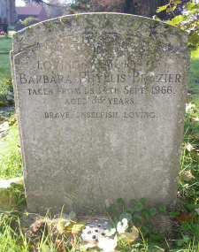 | In Loving Memory of  Barbara Phyllis Brazier  Taken from us 14th September 1966  Aged 33 years  Brave. Selfish. Loving
