Great Bradley Church, Suffolk: Grave Number 22
Peter Ioannides

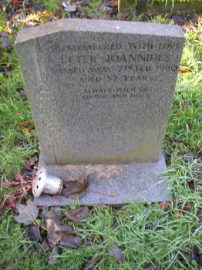 | REMBERED WITH LOVE  PETER IOANNIDES  PASSED AWAY 7TH FEB 1990  AGED 52 YEARS  ALWAYS WITH US  KISSES AND HUGS

