Great Bradley Church, Suffolk: Grave Number 216
Claire Elizabeth TAYLOR
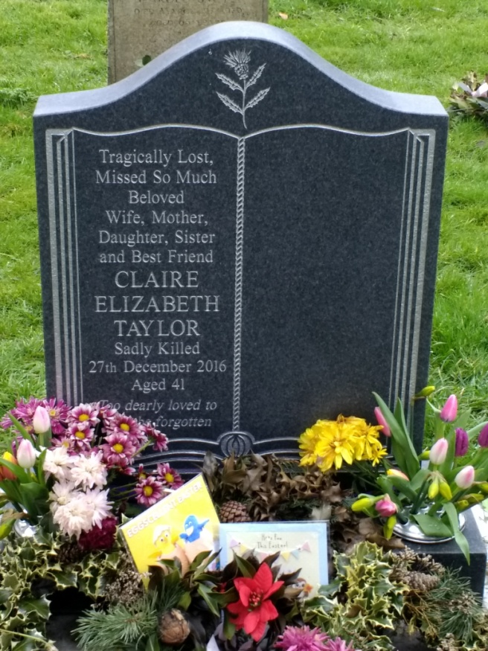 | Tragically lost. Missed So Much.  Beloved Wife, Mother, Daughter, Sister and Best Friend  CLAIRE ELIZABETH TAYLOR  Sadly killed  27th December 2006  Aged 41  Too dearly loved to be forgotten
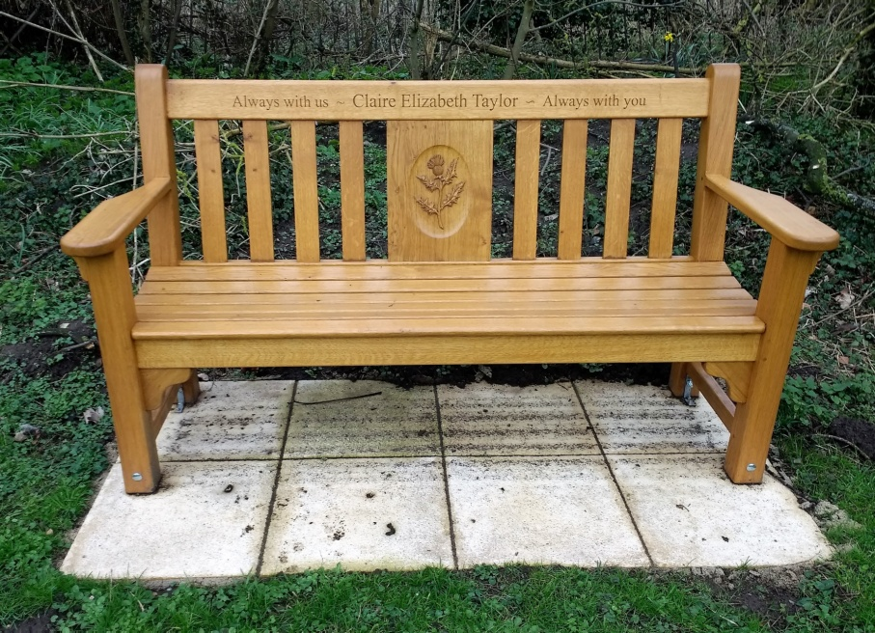
A seat has been erected in the graveyard in honour of Claire Taylor.
Clare died after being hit by a car at the bottom of Bradley Hill, whilst training for a marathon. A verdict of accidental death was recorded.

