Great Bradley Church, Suffolk: Grave Number 215
Nicky [Nick] Kelly

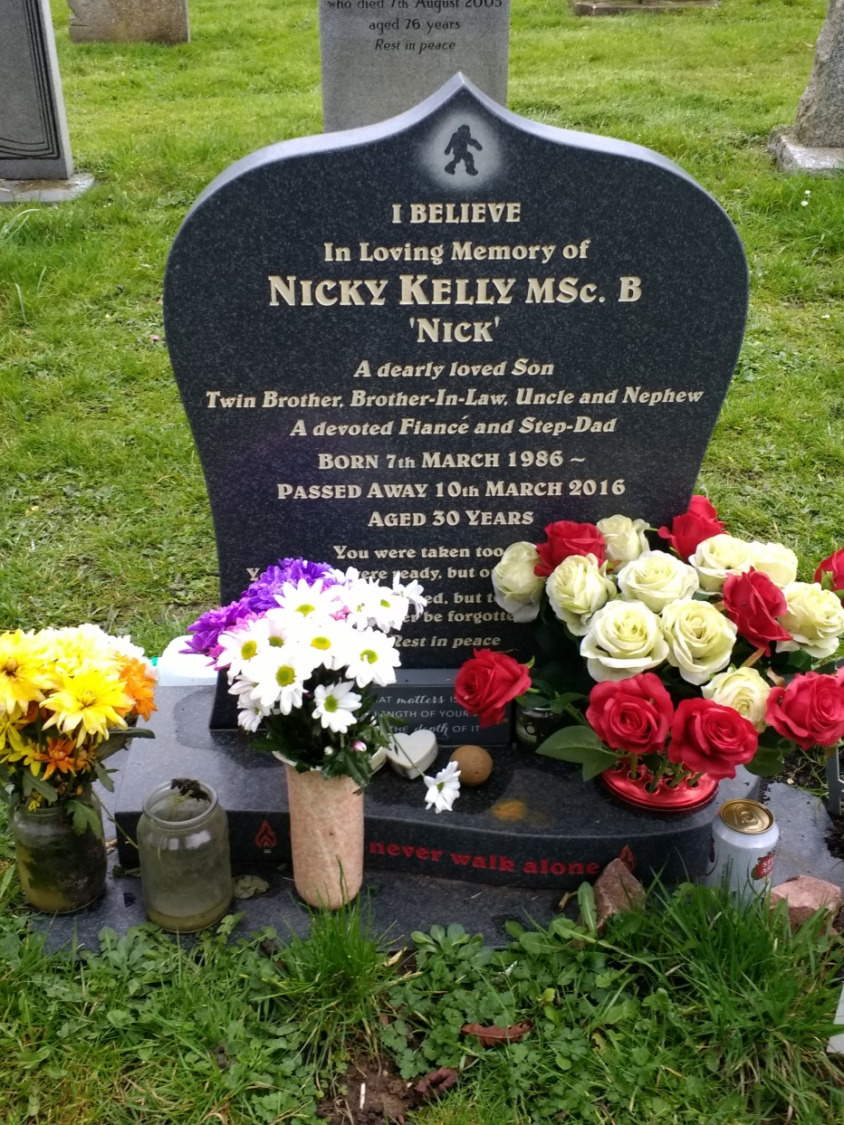
I Believe
A dearly loved son
Twin Brother, Brother-in-law, Uncle and Nephew
A devoted Fiancé and Step-Dad
Born 7th March 1986 ~
Passed away 10th March 2016
Aged 30 Years

