Great Bradley Church, Suffolk: Grave Number 210
Keith Lewis Hayward

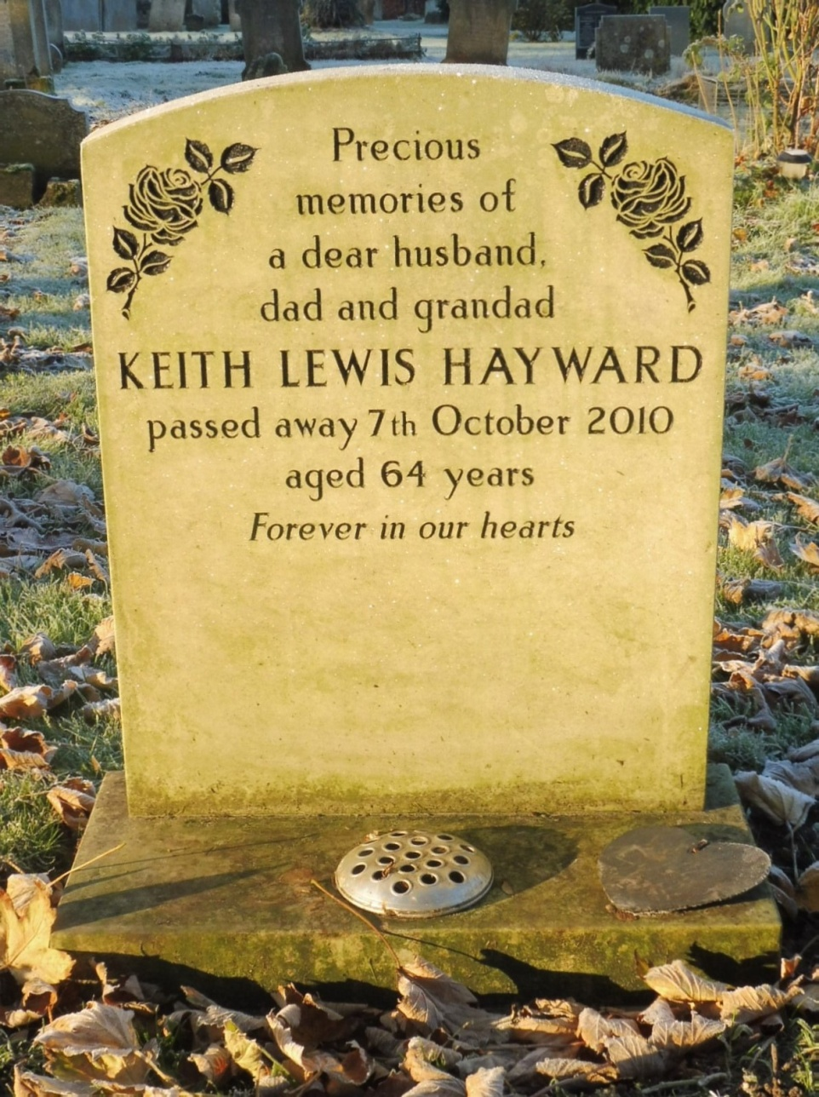
Precious memories of a dear husband, dad and granddad
KEITH LEWIS HAYWARD
passed away 7th October 2010
aged 64 years
Forever in our hearts

