Great Bradley Church, Suffolk: Grave Number 204
David Frederick Theodore Underwood

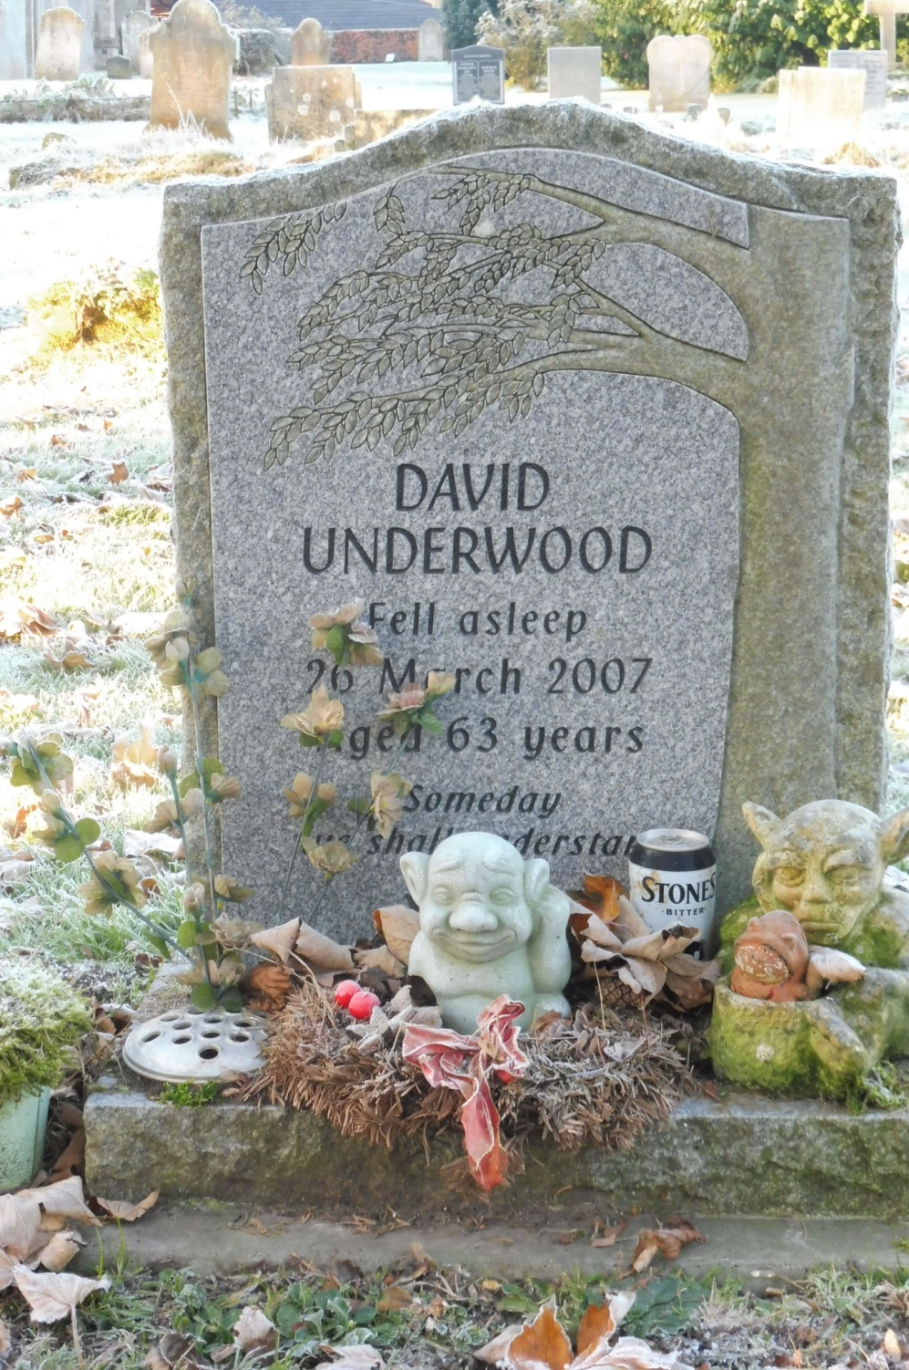 | David Frederick Theodore Underwood died 26th March 2007 aged 62 years.  A local agricultural worker David lived at Evergreen Lane.  Part of a large local family still living in the village.  A lover of cats.

