Great Bradley Church, Suffolk: Grave Number 203
Caroline Benet

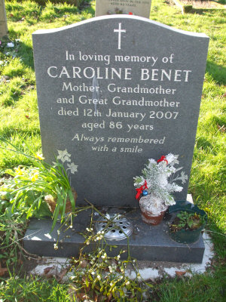 | Caroline Benet died 12th January 2007 aged 85 years. A talented local painter.  She lived at Willow Cottage next door to Sugar Loaf. The cottage was formerly the village post office.  A Grey Marble memorial was erected in 2007

