Great Bradley Church, Suffolk: Grave Number 1
Bertie Thomas Palmer and Gladys May Palmer

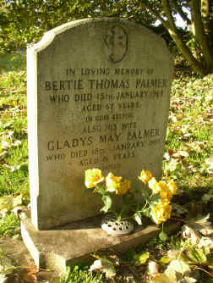 | IN LOVING MEMORY OF  BERTIE THOMAS PALMER  WHO DIED 15th JANUARY 1969  AGED 67 YEARS  IN GOOD KEEPING  ALSO HIS WIFE  GLADYS MAY PALMER  WHO DIED 18th JANUARY 1987  AGED 81 YEARS  REUNITED
