Great Bradley Church, Suffolk: Grave Number 198
Brian Taylor

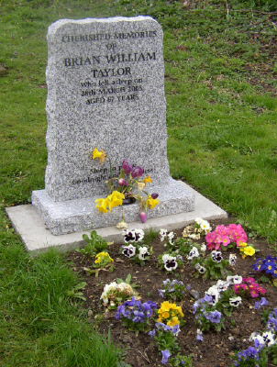 | CHERISHED MEMORIES  OF  BRIAN WILLIAM  TAYLOR  Who fell asleep on  28th March 2005  Aged 67 years  Sleep in Peace  Goodnight and God bless
Brian Taylor died 28th March 2005 Aged 67. Husband of June. Lived on Clarendale for 23 years. An appreciation of his life appeared in the Bradley Bugle April 2005.Brian Taylor is the final entry in the Burial Register 1933 onwards and now kept at the records office Bury St Edmunds.

