Great Bradley Church, Suffolk: Grave Number 193
Small Tomb Grave with engraving to resemble a body. There is a skull and arms and generally in the form of a body. This is the oldest gravestone in the churchyard. There are no similar graves in the graveyard.
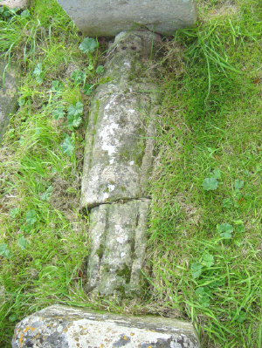
Inscriptions identified by an ancestor, Brian Norden, is as follows; The Head Stone has a skull at the top. Son of John Morden……?6 of…..1697./8? The Foot Stone son of John Morden born ye 26th of …… 1697 or 8. There are no other visible markings. Size would indicate child’s grave.
Grave193 Morden is known to be the ancestor of Brian Norden of Harborne, Birmingham who is maintaining an interest in them as part of Norden family history. [2004]. Further research from the Bishops Transcripts 1680-1705 is as follows;
1679 Eliz. Wife of Michael Norden buried 11th December.
1683 Michael Norden buried 15th December.
1684 /5 Elizabeth Norden daughter of Richard and Katherine buried September
1697? …….. Norden daughter of Richard and Mary buried 12th February

