Great Bradley Church, Suffolk: Grave Number 183
Catherine and Rebecca Collett and two unnamed children
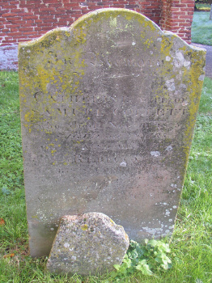 | IN MEMORY  OF  CATHERINE COLLETT WIFE OF  SAMUEL COLLETT  WHO DIED NOV 11 1825  AGED 30 YEARS  ALSO OF  REBECCA  HIS SECOND WIFE  WHO DIED NOV 21 1837  AGED 57 YEARS  ALSO OF TWO INFANT CHILDREN  ................. [eroded]  Footstone has  SC  1869

