Great Bradley Church, Suffolk: Grave Number 182
Samuel Collett

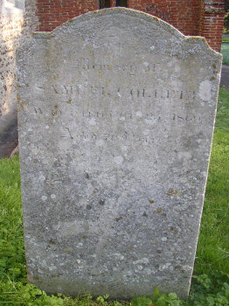 | IN  MEMORY  OF  SAMUEL COLLETT  WHO DIED OCT 25TH 1869  AGED 78 YEARS
