Great Bradley Church, Suffolk: Grave Number 177
Thomas Paxman
His parents are George and Martha George (No.178) and sister is Liz (No. 4)

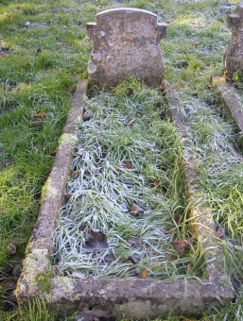 | IN LOVING MEMORY  OF  THOMAS GEORGE  PAXMAN  BORN OCT 2ND 1864  DIED FEB 7TH 1936  ASLEEP IN JESUS

