Great Bradley Church, Suffolk: Grave Number 175
GWLADYS PENNY RADCLYFFE

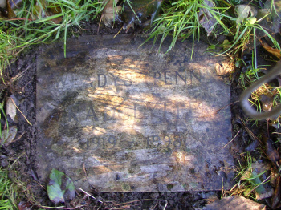

Small stone cremation tablet inscribed:
GWLADYS PENNY
RADCLYFFE
1919 - 1998

