Great Bradley Church, Suffolk: Grave Number 174
Mary and Edward Mizon
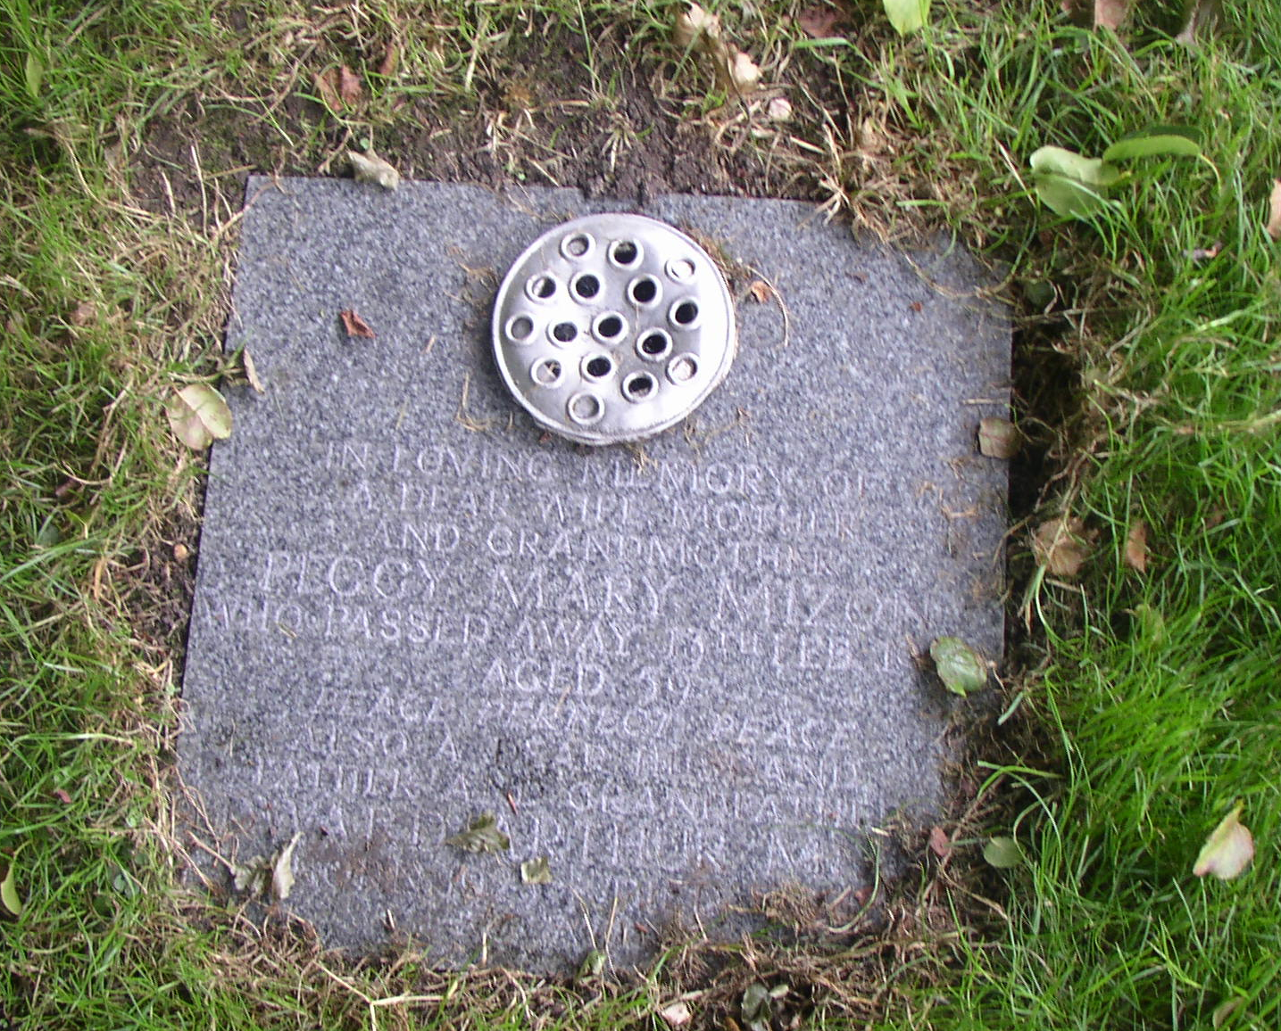
The marble cremation tablet is inscribed:
IN LOVING MEMORY OF
A DEAR WIFE AND MOTHER
AND GRANDMOTHER
PEGGY MARY MIZON
WHO PASSED AWAY 13 FEB 1990
AGED 59
PEACE PERFECT PEACE
ALSO OF A DEAR HUSBAND
FATHER AND GRANDFATHER
EDWARD ARTHUR MIZON
BORN 1925 DIED 1994
REUNITED

