Great Bradley Church, Suffolk: Grave Number 173
Jack Ryder
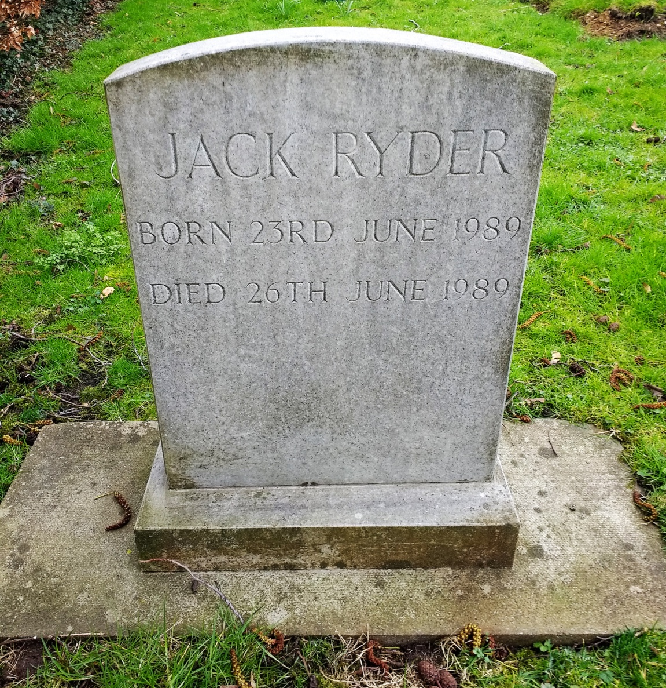
JACK RYDER
BORN 23RD JUNE 1989
DIED 26TH JUNE 1989

